Student Assessment Submission and Declaration
When submitting evidence for assessment, each student must sign a declaration confirming that the work is their own.
Student name: ADEL SHURAB  21023153 |  | Assessor name: Arar Al Tawil
Issue date (1St Submission):  16/04 | Submission date (1St Submission):  10/06 |  | Submitted on:
In case of resubmission
Issue date (1St Submission): | Submission date (1St Submission): |  | Submitted on:
Programme: Higher National Diploma in computing
Assignment number and title: Examine and understand the importance the data mining

TASK 1
Q1:
In the past 20-30 years, data mining was not as prevalent or sophisticated as it is today. The field of data mining was still in its infancy, and the technology and tools available were limited. Data mining was primarily used in large organizations or research institutions with substantial resources and specialized teams. The process of extracting valuable insights from large datasets was time-consuming and required significant manual effort. Additionally, the algorithms and techniques used in data mining were not as advanced as they are now, limiting the accuracy and depth of the analysis. Overall, data mining in the past was a relatively slow and resource-intensive process, yielding only modest results compared to its potential.
data mining has evolved significantly in recent years and has become an essential tool in various industries, including healthcare. There are several reasons why the Healthy Living Clinic should utilize data mining:
Improved patient care: By applying data mining techniques to patient health records and medical data, the clinic can identify patterns, correlations, and predictive models that can aid in diagnosing diseases, identifying risk factors, and suggesting effective treatment plans. This can lead to more personalized and precise healthcare interventions, ultimately improving patient outcomes.
Enhanced operational efficiency: Data mining can help the clinic streamline its operations by analyzing data related to patient flow, resource allocation, appointment scheduling, and inventory management. By identifying inefficiencies or bottlenecks, the clinic can optimize its processes, reduce costs, and improve overall productivity.
Data-driven decision making: With data mining, the clinic can make evidence-based decisions by analyzing vast amounts of data from various sources. This can include identifying trends in patient preferences, evaluating the effectiveness of different treatment protocols, or assessing the impact of specific interventions. By relying on data-driven insights, the clinic can make informed decisions that lead to better outcomes for both patients and the organization as a whole.
Q2:
Three theoretical founding concepts for data mining are::
Data Reduction:
Data reduction in data mining refers to the process of reducing the complexity and size of a dataset while preserving the essential information. This is achieved through techniques such as dimensionality reduction, feature selection, and sampling. Dimensionality reduction reduces the number of variables while maintaining relevant information. Feature selection focuses on selecting the most informative features while discarding irrelevant ones. Sampling involves selecting representative subsets of the data. Data cubes and aggregation techniques summarize and aggregate data at different levels of granularity. Data reduction improves the efficiency of data processing, especially for large-scale databases.

Data Compression:
Data compression in data mining aims to reduce the size or complexity of data by encoding it in a more concise representation. Compression techniques, such as association rule compression, decision tree pruning, cluster-based compression, and feature encoding, are used to achieve efficient storage, transmission, and analysis of data. Association rule compression represents rules in a concise form. Decision tree pruning removes redundant branches. Cluster-based compression stores only cluster assignments or centroids. Feature encoding represents data using fewer bits or symbols. Data compression enables faster data mining operations while minimizing the loss of information.

Pattern Discovery:
Pattern discovery is the process of identifying meaningful and interesting patterns in a dataset. It encompasses techniques such as association mining, classification models, sequential pattern mining, and clustering. Association mining discovers relationships among items. Classification models assign labels to instances based on their characteristics. Sequential pattern mining focuses on finding frequent patterns in sequences. Clustering group’s similar data instances together. Neural networks, including deep learning, are also used for pattern discovery. Pattern discovery enables insights, prediction, and optimization in various domains.
Q3:
Both traditional and modern approaches to data mining have their own strengths and weaknesses. Here is an evaluation of these approaches, highlighting key differences in their basic elements:
Traditional Approach to Data Mining:
Strengths:
Simpler methods and techniques are frequently used in traditional data mining methodologies, which makes them simpler and easier to grasp and use.
Interpretability: The outcomes produced by conventional methods are frequently easier to comprehend and explain, enabling analysts to identify and describe underlying patterns and linkages.
Established Techniques: Traditional data mining techniques have been in use for a long time, and numerous fields have validated their efficacy.
Weaknesses:
Limited Scalability: Traditional methods may have trouble with the large data of today's growing volume, diversity, and velocity. Large datasets or intricate data structures might not be handled by them effectively.
Lack of Flexibility: Conventional methods might not be adaptable enough to deal with changing data mining problems and new technology.
Performance Limitations: When working with complicated or high-dimensional data, traditional methodologies can not offer the best performance and efficiency.
Real-world example: In retail, a traditional approach to data mining may involve using association rule mining to identify patterns and relationships among products. For instance, finding that customers who buy diapers are also likely to purchase baby wipes.
Modern Approach to Data Mining:
Strengths:

Advanced Algorithms: Modern data mining approaches leverage more sophisticated algorithms and techniques, such as deep learning, neural networks, and ensemble methods, enabling more accurate and complex analyses.
Scalability: Modern approaches are designed to handle large-scale datasets efficiently, leveraging technologies like distributed computing and parallel processing.
Automation: Modern approaches often include automation capabilities, reducing the manual effort required and enabling faster and more efficient analysis.
Weaknesses:

Complexity: Modern data mining approaches can be complex, requiring advanced technical skills and expertise for implementation and interpretation.
Lack of Interpretability: Some modern techniques, like deep learning, may produce results that are difficult to interpret and explain, limiting their usability in domains where interpretability is crucial.
Data Quality and Preprocessing: Modern approaches may require high-quality and well-preprocessed data to achieve accurate and meaningful results, making data preparation a critical and time-consuming step.
Example: Using deep learning algorithms for medical image analysis is an example of a contemporary strategy. Deep learning models can scan vast quantities of medical images to find anomalies or help with diagnoses, providing more precise and effective interpretation of medical images.
It is challenging to say with certainty which method is superior for drawing important conclusions from huge datasets. Depending on the particular situation and requirements, both old and modern approaches have advantages and are appropriate. Modern approaches, on the other hand, typically offer more potent tools and methodologies to handle and extract insights from massive datasets due to the complexity and scale of data that is expanding in today's environment. They can make use of sophisticated algorithms, scalability, and automation to handle and analyze big data difficulties more precisely. Nonetheless, in order to choose the strategy that will produce the most insightful data, it is crucial to thoroughly evaluate the specific goals, limitations, and context of the data mining project.
Q4:
differences between clustering, classification, and regression:
Technique | Purpose | Input | Output | Supervised/Unsupervised
clustering | Group similar data points | Unlabeled data | Cluster assignments | Unsupervised
classification | Assign data to categories | labeled data | Class labels | supervised
regression | Predict a continuous value | labeled data | Continuous predictions | supervised

Q5:
Here are the algorithms for each technique mentioned:
Clustering: K-means algorithm
Classification: Random Forest algorithm
Regression: Linear Regression algorithm
the steps for the Linear Regression algorithm:
1-Pre-processing: the data involves handling category variables (encoding or dummy variables), handling missing values, and scaling or normalizing numerical characteristics as necessary. This guarantees that the data are prepared for regression analysis.
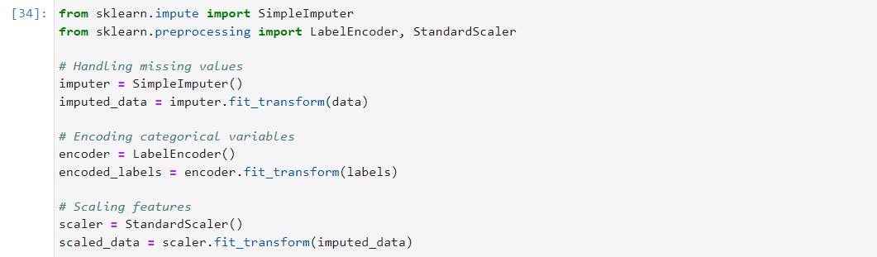
2-Splitting of the dataset: The training set and the testing set are two separate subsets of the dataset. The regression model is trained using the training set, and its performance is assessed using the testing set. The data is typically split at random, with 70–80% of the total data going to training and 20–30% going to testing.
3-Regression modeling is the process of identifying the line that best fits the data and minimizes the difference between the anticipated and observed values. In order to assess each input feature's influence on the target variable, the algorithm estimates the coefficients for each feature. It is possible to write the model equation as Y = b0 + b1X1 + b2X2 +... + bn*Xn, where Y is the target variable, b0 is the intercept term, and b1, b2,..., bn are the coefficients for the corresponding input features X1, X2,..., Xn.
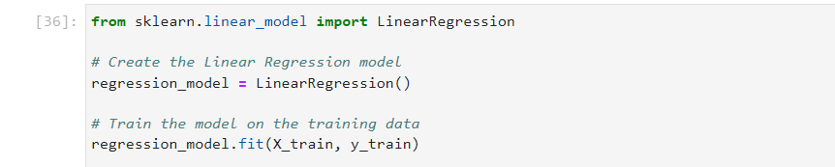
4-evaluating the model Several measures, including mean squared error (MSE), root mean squared error (RMSE), and R-squared (R2) value, are used to assess the performance of the model. These indicators assess how accurately the model predicts the desired variable. Higher values for R2 signify a better fit of the model to the data, whereas lower values for MSE and RMSE signify better performance. The assumptions of the linear regression model can further be evaluated using additional diagnostic plots and methods, such as examining the residuals for homoscedasticity and normality.
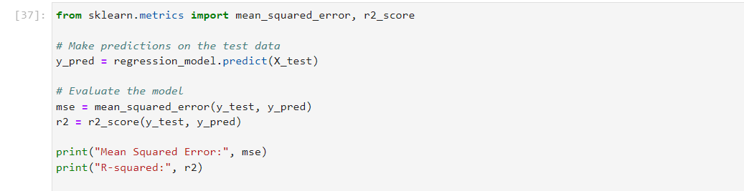
Q6:

Classification:

Classification involves grouping patients into pre-defined classes or categories based on their attributes. This task helps predict patient outcomes and identify individuals at risk for specific diseases or conditions. The process consists of several stages. First, the data is preprocessed by handling missing values, encoding categorical variables, and scaling features. Then, the dataset is split into training and testing subsets. An appropriate classification algorithm, such as decision trees, logistic regression, or support vector machines, is selected. The model is trained on the training data to learn the patterns and relationships between patient attributes and their corresponding classes. Finally, the model's performance is evaluated using the testing data, considering metrics like accuracy, precision, and recall. Classification provides valuable insights for treatment planning, resource allocation, and personalized patient care.
Regression:
Regression aims to establish a predictive relationship between patient attributes and a continuous target variable, such as age or blood pressure. This task helps in predicting and estimating patient-related continuous variables, aiding in prognosis, treatment planning, and resource allocation. The stages involved in regression are similar to classification. The data is preprocessed to handle missing values, encode categorical variables, and scale features. The dataset is then split into training and testing subsets. An appropriate regression algorithm, such as linear regression, random forest regression, or neural networks, is chosen. The model is trained on the training data to learn the patterns and relationships between patient attributes and the target variable. The model's accuracy and goodness of fit are evaluated using metrics like Mean Squared Error (MSE) or R-squared. Regression analysis helps identify factors that influence patient outcomes or disease progression.
Clustering:
Clustering involves grouping patients into clusters or segments based on their similarities or patterns in the dataset. This task helps in patient segmentation for targeted marketing, personalized treatment plans, or identification of patient subgroups with similar characteristics or disease risks. The stages of clustering include data preprocessing, where missing values are handled, categorical variables are encoded, and features are scaled. An appropriate clustering algorithm, such as k-means, hierarchical clustering, or DBSCAN, is selected. The number of clusters is defined either based on domain knowledge or using techniques like the elbow method or silhouette coefficient. The data is then clustered, assigning patients to different clusters based on their attribute similarities. The clusters are analyzed and interpreted to understand the characteristics and profiles of patients within each cluster, revealing patterns and insights.
By choosing the appropriate task (classification, regression, or clustering) and following the outlined stages, clinics can gain valuable insights from patient data, improve decision-making, enhance patient care, and optimize resource allocation. The specific benefits depend on the chosen task and the clinic's objectives.
Q7:
Descriptive data mining tasks play a crucial role in helping organizations better understand their data and improve the accuracy of their predictive models. Here's an explanation of how descriptive tasks can achieve these objectives with an example:
1-Finding patterns and relationships in the data is possible with descriptive data mining techniques like association rule mining and sequence analysis. Organizations can find common item sets or event sequences that co-occur or follow a specific pattern by studying historical data. This comprehension of relationships can help businesses make better informed decisions by illuminating the interdependencies between variables.
Example: The company learns from association rule mining on previous transaction data that customers who buy sunscreen lotion also frequently buy beach towels. The relationship between these two things is revealed by this insight, which helps the business better understand client behavior. By adding the association rule as a feature, the company can use this information to increase the precision of their sales forecast model.
2-Data profiling and summary statistics computation: Descriptive tasks entail data profiling and summary statistics computation. Organizations may fully comprehend their data by looking at the distribution of the variables, spotting outliers, and computing measurements like mean, median, or standard deviation. This information aids in recognizing data quality problems, comprehending the data's unpredictability, and spotting potential biases.
Example: A healthcare institution wants to create a prediction model to find those who are most likely to get chronic illnesses. They find out through data profiling that a certain attribute, like BMI (Body Mass Index), has a large number of missing values. This realization motivates the company to solve the missing data issue and take into account imputation techniques to improve the precision of their predictive models.
3-Data visualization: When doing descriptive tasks, it is common to visualize the data using graphs, charts, or other visual aids. Visualizations are useful for investigating relationships between variables, understanding the distribution of data, and spotting outliers. They offer a visual summary of the data, enabling businesses to swiftly and nimbly gather insights.
Example:An e-commerce company, for instance, wishes to enhance the design of its website to boost user interaction and conversion rates. Customers' clickstream data is shown, and this allows companies to see which pages have lower clickthrough rates or greater bounce rates. With the aid of this visualization, the company is better able to comprehend the customer journey, revamp certain pages, and increase the precision of their customer behavior prediction models.
Task2:
Q1:
Python is widely used as a programming language for data mining activities due to its versatility and rich ecosystem of libraries and tools. Here are a couple of features in Python that are useful for data mining activities:
1-Numerous strong libraries are available in Python, many of which were created expressly for data mining and analysis. The following are a some of the most popular libraries:
NumPy: a core Python module that supports massive, multi-dimensional arrays, mathematical operations, and numerical computing.
Pandas is a flexible library for analyzing and manipulating data. It provides data structures like dataframes that make managing and preparing data effective.
A well-known machine learning library called Scikit-learn offers a variety of methods and tools for jobs like classification, regression, clustering, and dimensionality reduction.
Libraries for data visualization, Matplotlib and Seaborn, allow the production of perceptive plots, charts, and graphs.
2-Simple syntax: Python is user-friendly for beginners and allows for the effective implementation of data mining jobs thanks to its clear and simple-to-understand syntax. Users can quickly build, test, and alter code for various data mining operations thanks to its readability and simplicity.
3-Python is appropriate for data mining tasks that entail several components due to its interoperability with other programming languages and tools. For example, Python may operate with big data processing frameworks like Apache Spark or Hadoop or be used in conjunction with SQL for database queries.
4-Community and support: The Python programming language has a thriving and active community of data scientists, researchers, and developers who support each other, produce libraries, and exchange expertise. This community-driven ecosystem offers a plethora of tools, training, and documentation for data mining operations and guarantees ongoing improvements.
5-Scalability: For scaling data mining activities, Python offers a number of alternatives. Large datasets can be processed in parallel via libraries like Dask and Apache Spark, enabling distributed computing. Python's scalability capabilities make it suited for managing huge data and successfully completing challenging data mining tasks.
Q2: The following is a description of each process of text mining using the Python programming language:
Tokenization:
is the division of text into tokens, which are smaller parts. Text must be divided into sentences or words in order to be suitable for analysis.
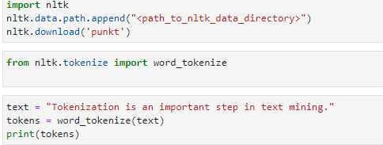
part--of-speech (POS)
Each word in a text is given a part of speech (such as a noun, verb, or adjective) by POS tagging, which makes it easier to analyze sentence structure and extract pertinent information.
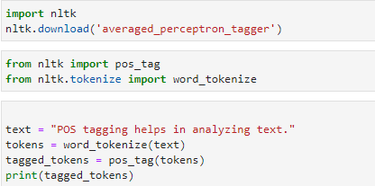
Stemming:
Words are derived from their base or root form through the process of stemming. It assists in reducing word variations to their most basic form. Numerous stemming algorithms are offered by the nltk library.
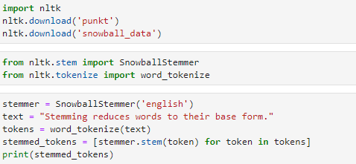
Stop Words:
Stop words, which are frequently found in a language but have little to no meaning, are frequently eliminated from text during preprocessing. The NLTK library for Python provides prepared lists of stop words for several languages. Words like "and," "the," "is," etc. are considered stop words. By eliminating stop words, the emphasis is shifted to the text's more significant and meaningful terms, enhancing analysis and lowering noise.
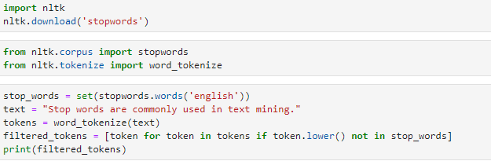
Named Entity Recognition (NER):
The process of locating and categorizing named entities (such as names of individuals, organizations, places, and dates) in text is known as named entity recognition. Python has libraries with NER capabilities, like as NLTK and spaCy. These libraries enable tasks like entity extraction, relationship extraction, and knowledge graph generation by recognizing and extracting named entities from text using machine learning methods.
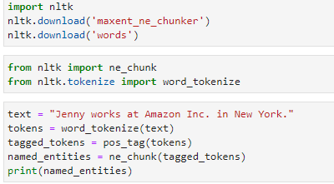
Feature Extraction:
In feature extraction, text input is converted into a numerical form that machine learning algorithms can understand. TF-IDF and Bag-of-Words are common strategies. Tools for feature extraction are available through the Sklearn library.
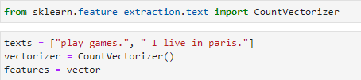

Q3: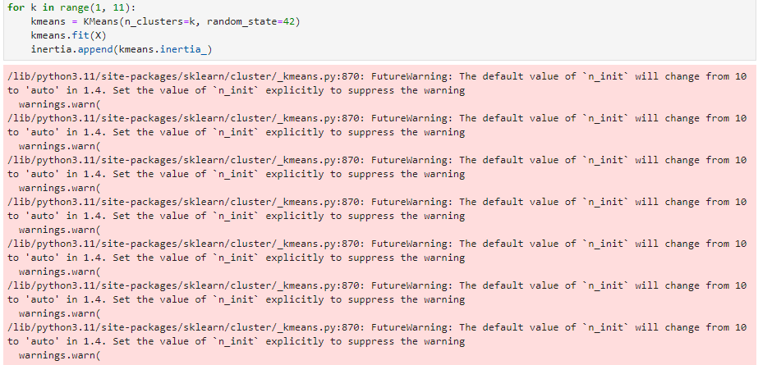
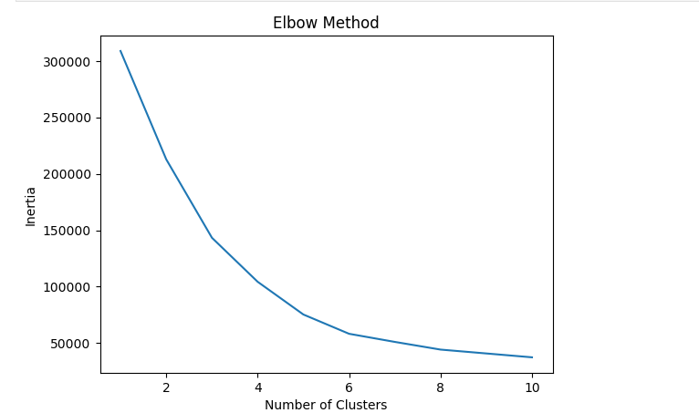
Task3:
Q1:
Text mining is the process of obtaining valuable facts and insights from unstructured text data, and it can be used by a clinic to analyze user reviews of the clinic. To analyze and comprehend textual data, it uses methods including machine learning, information retrieval, and natural language processing (NLP).
Benefits of text mining in analyzing user reviews for a clinic:
1-emotion analysis: Text mining can be used to determine whether user reviews are expressed with positive, negative, or neutral emotion. This data can offer insightful information about patients' general levels of satisfaction and assist the clinic in identifying areas for growth or strength.
2-The clinic can determine the main themes or subjects covered in the user reviews by employing text mining techniques like topic modeling. In order to focus on particular areas for improvement or to address complaints, it is helpful to discover which features of the clinic's services or facilities are commonly highlighted by patients.
3-Feedback analysis: Text mining can uncover specific feedback or opinions expressed by users in their reviews. This feedback can provide valuable suggestions for improvement, highlight areas of excellence, and help the clinic prioritize actions based on patient needs and preferences.
Applying text mining to analyze user reviews about the clinic:
1-Data collection: Compile user reviews from a variety of sources, including online review sites, social media, and survey replies.
2-Text preprocessing: Remove noise from the text data by removing stopwords, special characters, and punctuation. To divide up the text into separate words or phrases, use tokenization techniques.
3- sentiment analysis: algorithms to identify each review's sentiment polarity (positive, negative, or neutral). You can accomplish this by either training your own model on labeled data or using pre-trained sentiment analysis methods.
4-Topic extraction: To extract the key subjects or themes stated in the user evaluations, employ topic modeling techniques like Latent Dirichlet Allocation (LDA) or Non-Negative Matrix Factorization (NMF). This aids in comprehending the common issues or strengths among patients.
5-feedback analysis: Track down specific words or phrases that represent user comments or thoughts. Techniques like named entity recognition and keyword extraction can be used for this.
6-Visualization and reporting: Use interactive dashboards, word clouds, or other visually appealing and understandable visuals to present the results. This makes it simple for the clinic to understand the insights and decide using the data.
Q2:
The following is a description of each process of text mining using the Python programming language:
Tokenization: is the process of separating a text into tokens, such as individual words or phrases. The Natural Language Toolkit (NLTK) package in Python offers a number of tokenization techniques, including sentence and word tokenization. Sentence tokenization separates the text into individual sentences, whereas word tokenization breaks it up into words. Tokenization is a crucial stage in text mining since it enables more in-depth examination and processing of the text.
part--of-speech (POS)
The technique of giving each word in a sentence a grammatical tag indicating its syntactic category (noun, verb, adjective, etc.) is known as part-of-speech tagging. Through algorithms like the Maxent POS Tagger and the Perceptron POS Tagger, the NLTK library for Python offers POS tagging functionalities. For tasks like sentiment analysis, named entity recognition, and information extraction, POS tagging aids in comprehending the grammatical structure of the text.
Stemming:
Stemming is the process of condensing words to their stem, or root, form. It aids in bringing different word forms together into a single structure. The PorterStemmer and SnowballStemmer stemming algorithms are included in Python's NLTK module. Stemming, for instance, would change the words "running," "runs," and "ran" to their typical stem "run." By putting related words together, stemming helps to improve text analysis and reduce dimensionality.
Stop Words:
Stop words, which are frequently found in a language but have little to no meaning, are frequently eliminated from text during preprocessing. The NLTK library for Python provides prepared lists of stop words for several languages. Words like "and," "the," "is," etc. are considered stop words. By eliminating stop words, the emphasis is shifted to the text's more significant and meaningful terms, enhancing analysis and lowering noise.

Named Entity Recognition (NER):
The process of locating and categorizing named entities (such as names of individuals, organizations, places, and dates) in text is known as named entity recognition. Python has libraries with NER capabilities, like as NLTK and spaCy. These libraries enable tasks like entity extraction, relationship extraction, and knowledge graph generation by recognizing and extracting named entities from text using machine learning methods.
Feature Extraction:
In feature extraction, text is transformed into a numerical form that machine learning models can comprehend. The TF-IDF (Term Frequency-Inverse Document Frequency) and word embeddings (such as Word2Vec and GloVe) are only a few of the feature extraction techniques offered by Python's scikit-learn module. The key semantic information is preserved while text data is converted into numerical feature vectors using these techniques. When using machine learning algorithms for text mining tasks like classification, clustering, and regression, feature extraction is crucial.
These procedures make it possible to preprocess, analyze, and comprehend textual data in text mining using Python. They make it possible to do operations like tokenizing text, assigning grammatical tags, breaking down words into their simplest forms, getting rid of unnecessary words, identifying named entities, and turning text into numerical features. A wide range of tools and methods are available in Python's libraries for effectively implementing these procedures in text mining applications.
Q3:
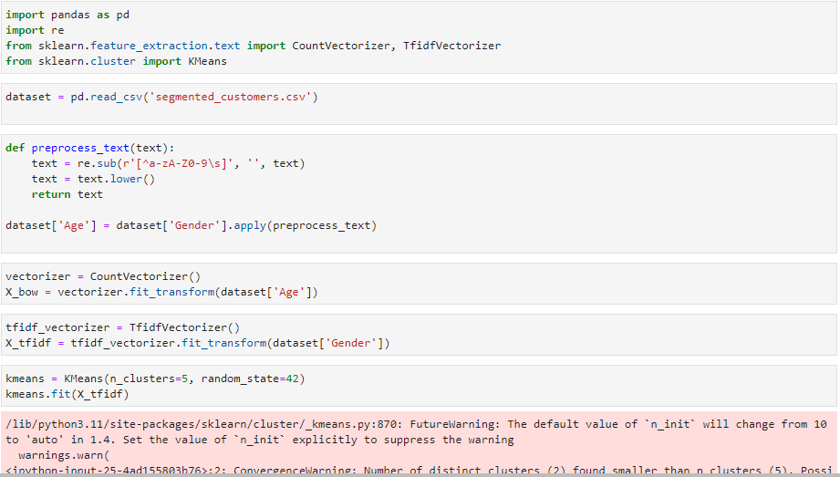
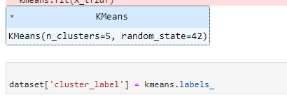
I created the code to load the dataset, import the required libraries, preprocess the text data by stripping out special characters and changing it to lowercase, apply Bag-of-Words and TF-IDF for feature extraction, perform text clustering using the KMeans algorithm, and assign cluster labels to the dataset for additional analysis.
Task4:
Q1:
The process of obtaining priceless insights, patterns, and information from graph-structured data is known as graph data mining. Graphs are an effective tool for representing and analyzing intricate connections and interactions between different elements. In order to find hidden patterns, conduct graph-based analytics, and acquire a deeper understanding of the underlying structure and dynamics of the data, graph data mining entails using a variety of approaches and algorithms. Here are three interesting and practical graph data mining examples:
The process of obtaining knowledge and insights from graph-structured data is known as graph data mining. It has uses in many different fields, including bioinformatics, recommender systems, social network research, and many more. Graph data mining offers a deeper understanding of complicated relationships, facilitates decision-making, and promotes creative applications in a variety of industries by utilizing the strength of graph-based representations and algorithms.
1-Analysis of Social Networks: Social networks can be visualized as graphs, with nodes representing individuals and edges representing connections between them. It is possible to examine social networks and derive valuable insights using graph data mining tools. Detecting communities or groups of people with shared interests, studying the dissemination of information or influence within the network, and predicting user behaviors or preferences based on their network connections are a few examples of how to identify influential people or communities within social networks.
2-Systems that provide recommendations: Systems that make recommendations frequently use graph data mining techniques to offer tailored advice. Algorithms can examine the network structure and find commonalities between users or items by graph-representing users, items, and their interactions. In order to make recommendations for goods, media, or music based on the tastes of similar users, collaborative filtering algorithms, for instance, can use graph-based similarity measurements. On the basis of the relationships and interactions between already-existing things, graph-based recommendation systems also make it possible to find new, pertinent objects.
3-Bioinformatics: The analysis of biological networks, such as protein-protein interaction networks, gene regulatory networks, or metabolic networks, uses graph data mining extensively. Graph mining techniques can be used to analyze the overall structure and dynamics of biological systems, anticipate the activities or interactions of proteins, locate signaling pathways, and uncover significant nodes or proteins in biological networks. Researchers can learn more about intricate biological processes and advance the development of drugs, disease detection, and personalized treatment by using graph algorithms.
Q2:
Graph algorithms are well-suited for graph pattern mining, graph classification, and graph clustering tasks. However, the performance and accuracy of these algorithms can vary depending on the specific problem and dataset. Here is an estimation of how well graph algorithms typically work in each task:
1-Graph Pattern Mining:Discovering frequent subgraphs or patterns within a graph dataset is the goal of graph pattern mining. The efficiency of the chosen approach, the size and complexity of the network, the density of the patterns, and other variables all affect how well graph pattern mining techniques perform. Although accurate graph pattern mining can be computationally expensive, scalable or approximative techniques have been developed to effectively handle large-scale graphs.
Typical algorithm: A well-liked approach for graph pattern mining is apriori-based frequent subgraph mining (AFSM). Similar to the Apriori algorithm for frequent itemset mining, it uses the idea of association rule mining. By repeatedly extending and trimming infrequent subgraphs, AFSM finds frequent subgraphs.
2-Graph classification is categorizing or labeling complete graphs in accordance with their structural characteristics. The discriminative features extracted from the graphs and the selected classification method determine how well graph classification algorithms perform. In order to represent and categorize graphs, various algorithms use a variety of techniques, such as graph kernels, graph neural networks, or graph-based feature extraction.
Typical algorithm: For graph classification, Graph Convolutional Networks (GCNs) are a well-liked algorithm. To learn representations that capture graph-level information, GCNs take advantage of graph structure and node properties. They directly apply convolutions to the graph, which enables efficient feature extraction and classification.
3-Graph clustering: Based on connection or similarity patterns, a graph is to be divided into groups or clusters. The capacity to locate coherent and well-separated clusters inside the graph is a criterion for how effectively a graph clustering method performs. The qualities of the network's size, density, and connectivity can have an impact on how well graph clustering methods perform.
Typical algorithm: A popular graph clustering approach is spectral clustering. It does dimensionality reduction using the graph Laplacian matrix's eigenvalues and eigenvectors, and then uses conventional clustering methods, like k-means, on the smaller representation.
Python is a well-liked computer language that is employed in graph data mining. For working with graph data and implementing graph algorithms, Python offers a variety of tools and frameworks, including NetworkX, Graph-tool, and igraph.
Gephi is a popular program for using graph algorithms. Gephi is free software that may be used to visualize, explore, and conduct graph analytic tasks. For tasks like community recognition, centrality analysis, and network visualization, it offers a user-friendly interface and supports a variety of graph techniques.
Q3:
Graph clustering implementation example:
I'll take a look at the graph clustering task I described before and give an example of how to do it in Python with NetworkX and the Louvain algorithm:

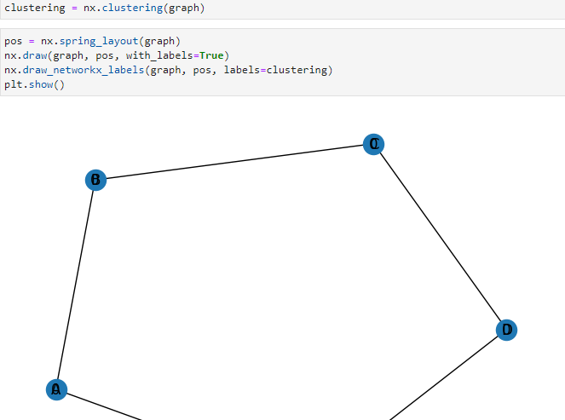
I first design a graph with nodes and edges for this example. I then use NetworkX's community.best_partition method to implement the Louvain algorithm. Each node receives a cluster ID from the algorithm based on the modularity optimization. I print the clusters to see which nodes are a part of each cluster before finishing.
Q4:

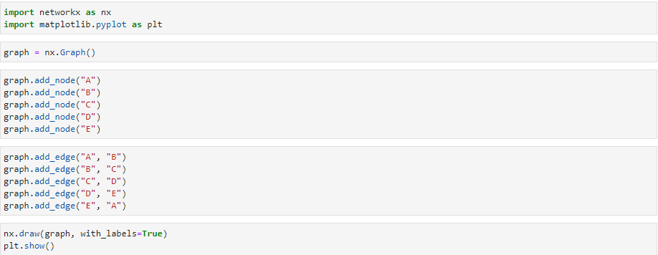
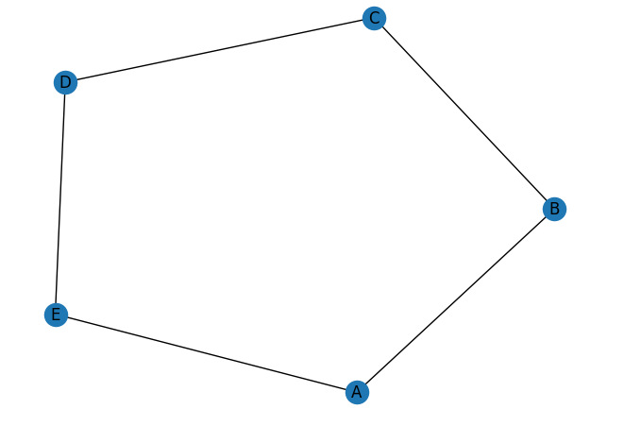

For a housing dataset, I implement completes the following tasks: loading the data, putting it through preprocessing, using NetworkX to create a graph representation, and performing graph mining operations like degree centrality, community detection, centrality measures, and graph visualization.

Plagiarism
Plagiarism is a particular form of cheating. Plagiarism must be avoided at all costs and students who break the rules, however innocently, may be penalised. It is your responsibility to ensure that you understand correct referencing practices. As a university level student, you are expected to use appropriate references throughout and keep carefully detailed notes of all your sources of materials for material you have used in your work, including any material downloaded from the Internet. Please consult the relevant unit lecturer or your course tutor if you need any further advice.
Student Declaration
Student declaration
I certify that the assignment submission is entirely my own work and I fully understand the consequences of plagiarism. I understand that making a false declaration is a form of malpractice.

Student signature: Date:

